ShopNest Store Analytics Dashboard Report
DA-202512-1 Submitted by: Pragati Priyadarshni

INTRODUCTION

The ShopNest Store dataset represents an e-commerce platform in Portugal.
The objective of the project is to analyze sales, customer behavior, product performance, and delivery efficiency using Power BI. The dashboard provides insights into sales trends, ratings, delayed orders, payment methods, and regional performance.

DATASET DESCRIPTION
9 datasets are used:
Example table:
Dataset | Description
Customers | Customer location information
Geolocation | Geographic coordinates of zip codes
Orders | Order details and timestamps
Order Items | Products included in each order
Order Payments | Payment methods and values
Order Reviews | Customer review scores
Products | Product details and categories
Sellers  Product Category | Seller information  Portuguese to English translation
DATA MODEL
The Power BI dashboard is built using a relational data model that integrates multiple datasets related to customers, orders, products, payments, reviews, and sellers. The model follows a star-schema-like structure, where the orders table acts as the central table connecting most transactional data.
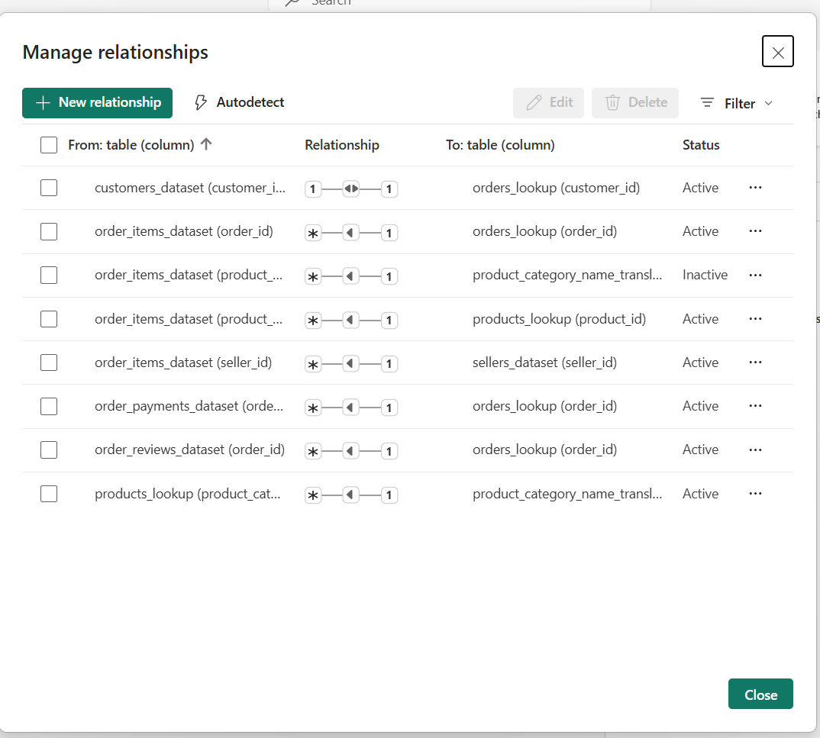The orders_lookup table serves as the primary table that links customer information with order-related datasets. The customers_dataset is connected to the orders table through the customer_id, allowing customer location and demographic data to be associated with each order.
The order_items_dataset is connected to the orders table through order_id, enabling analysis of the products purchased in each order. This table also links to the products_lookup table using product_id, which provides detailed information about the products sold.
Product information is further enriched by connecting the products_lookup table to the product_category_name_translation table through product_category_name, allowing product categories to be translated into English for easier analysis and visualization.
The order_payments_dataset is linked to the orders table via order_id, providing insights into customer payment methods and transaction values. Similarly, the order_reviews_dataset is connected through order_id, enabling analysis of customer satisfaction through review scores.
Additionally, the order_items_dataset is connected to the sellers_dataset through seller_id, allowing the analysis of seller performance and distribution.
Overall, the relationships in the data model ensure seamless integration of transactional, product, customer, and review data, enabling comprehensive analysis of sales performance, delivery efficiency, customer behavior, and product quality within the ShopNest e-commerce platform.

DASHBOARD STRUCTURE & NAVIGATION
The Power BI dashboard is organized into three main analytical pages to present insights from the ShopNest dataset in a clear and structured manner.
The first page: Executive Overview
It summarizes overall business performance using key metrics such as Total Sales, Avg Rating, Total Orders & Net Revenue. This page provides a quick snapshot of the company’s performance.
Visuals include: Sales_Wise Top 10 Product Categories, State-Wise Sales Analysis (Map) with its explanatory chart, Seasonal Sales Pattern (Quarterly), Revenue Analysis (Yearly) and Payment Method Distribution.
The second page: Operational Analysis
It focuses on operational trends including visuals that help identify patterns in order processing, delivery efficiency, and regional operational performance.
Visuals include: Monthly Comparison Of Delayed & On-Time Orders, Category-wise Delayed Orders Count, Monthly Orders Trend, Customer State-wise Orders Strength (as an additional aid in further findings wrt delays.)
The third page: Product Insights
It analyzes product performance and customer feedback through different visuals.
Visuals Include: Highest and lowest rated products, State-wise Most Popular Product Categories.
All pages are connected through navigation buttons, allowing easy switching between sections. Drill-through functionality is also implemented to provide detailed Delivery Analysis from operational visuals- Monthly Comparison Of Delayed & On-Time Orders. This structure ensures smooth navigation and better understanding of the insights presented in the dashboard.
The dashboard also includes slicers positioned on the side panel to allow users to dynamically filter the visualizations. These slicers enable filtering of the data based on key attributes such as Year, Product Category, Payment Method & Customer State.
(NOTE: The pages switch by clicking on the purple rectangle under each page title. On each page, the corresponding title highlights with white colour.)

Dashboard Analysis Section Of The Eight Tasks

TASK 1: Top Categories by Total Price
Question: Which product categories generate the highest total sales revenue in the ShopNest store?
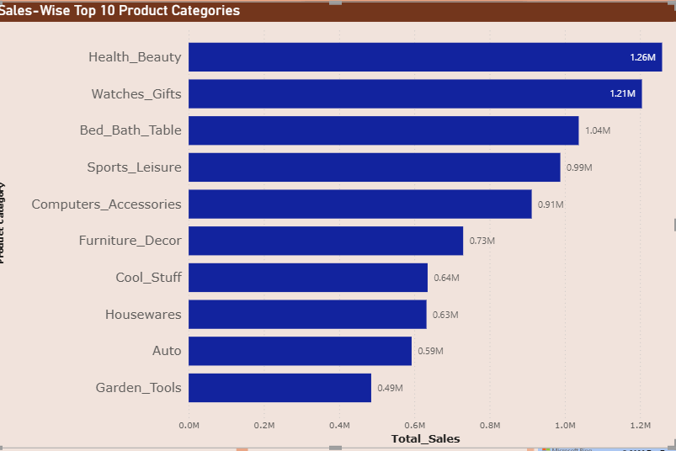
This visualization helps identify the best-performing product categories in terms of total sales revenue. Understanding these high-performing categories can help the business focus on inventory management, marketing strategies, and supplier partnerships to further increase revenue and customer satisfaction.

Key Insights & Findings:
- Health_Beauty is the highest revenue-generating category , indicating strong customer demand for personal care and wellness products.
- Watches_Gifts and Bed_Bath_Table also contribute significantly to overall sales, showing high consumer interest in lifestyle and home-related products.
- The presence of categories such as Sports_Leisure and Computers_Accessories suggests steady demand for recreational and technology products.
- The top 10 categories together represent a major portion of the store’s total sales, highlighting the most profitable product segments for the business.

TASK 2: Delayed Orders Analysis
Question: Which product categories experience the highest number of delayed deliveries?
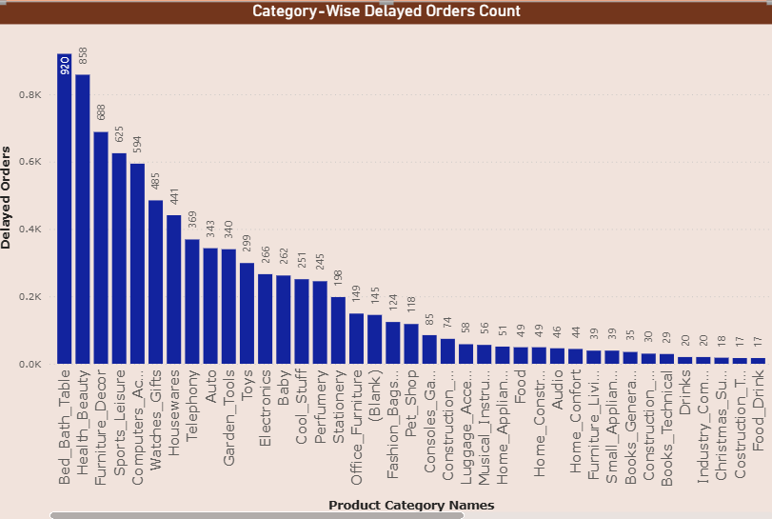
This chart shows the number of delayed orders across different product categories. A delay occurs when the actual delivery date exceeds the estimated delivery date. The visualization helps identify categories that frequently experience delivery delays, which may indicate logistical challenges, supplier issues, or high demand. By recognizing these patterns, the business can improve shipping processes, optimize inventory distribution, and reduce delays to enhance customer satisfaction.

Key Insights & Findings:
- The categories Bed_Bath_Table and Health_Beauty show the highest number of delayed orders.
- Furniture-related categories also experience notable delivery delays, likely due to larger product size and complex shipping requirements.
- Electronics and telephony products show moderate delay levels, suggesting relatively stable but still improvable supply chain performance.
- Several niche categories such as Food & Drink and Construction Tools have very low delay counts, indicating lower demand or efficient delivery handling.
Overall, delivery delays are concentrated in a few high-demand categories rather than evenly distributed across all product segments.

TASK 3: Monthly Comparison of Delayed vs On-Time Orders
Question: How does the number of delayed orders compare with on-time deliveries across different months?
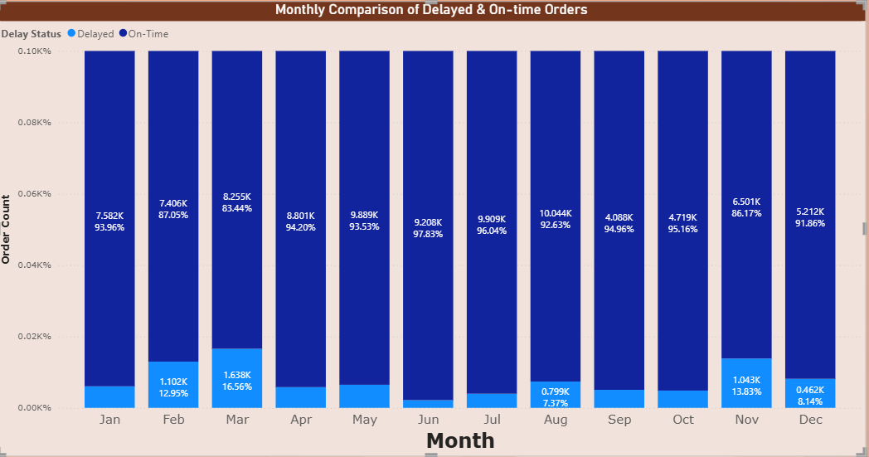
This visualization compares the number of on-time and delayed deliveries across different months. The chart helps analyze the delivery performance trend over time by showing how frequently orders were delivered on schedule versus delayed.

Key Insights and Findings:
- The chart shows that delivery delays were comparatively higher during the months of February, March & November.
- On-time deliveries were highest in August.
- The trend suggests that delivery efficiency varies across months, possibly due to seasonal demand, order volume, or operational factors.

- DRILLTHROUGH CROSS-REPORT:
The drillthrough cross-report feature has been used in this chart to provide a detailed analysis of late and on-time deliveries. A separate page- “Delivery Details” has a drillthrough overview from the chart inserted above. It has a table with additional details wrt delays.

A bar chart shows “State-wise delays” in Portugal. There is another chart “Rating Impact wrt Delays” that indicates how delayed deliveries have impacted the average review score by customers. We can conclude here that an efficient timely delivery management would significantly improve the Average Review Score.
Slicers are also attached to view month-wise trends on this page.
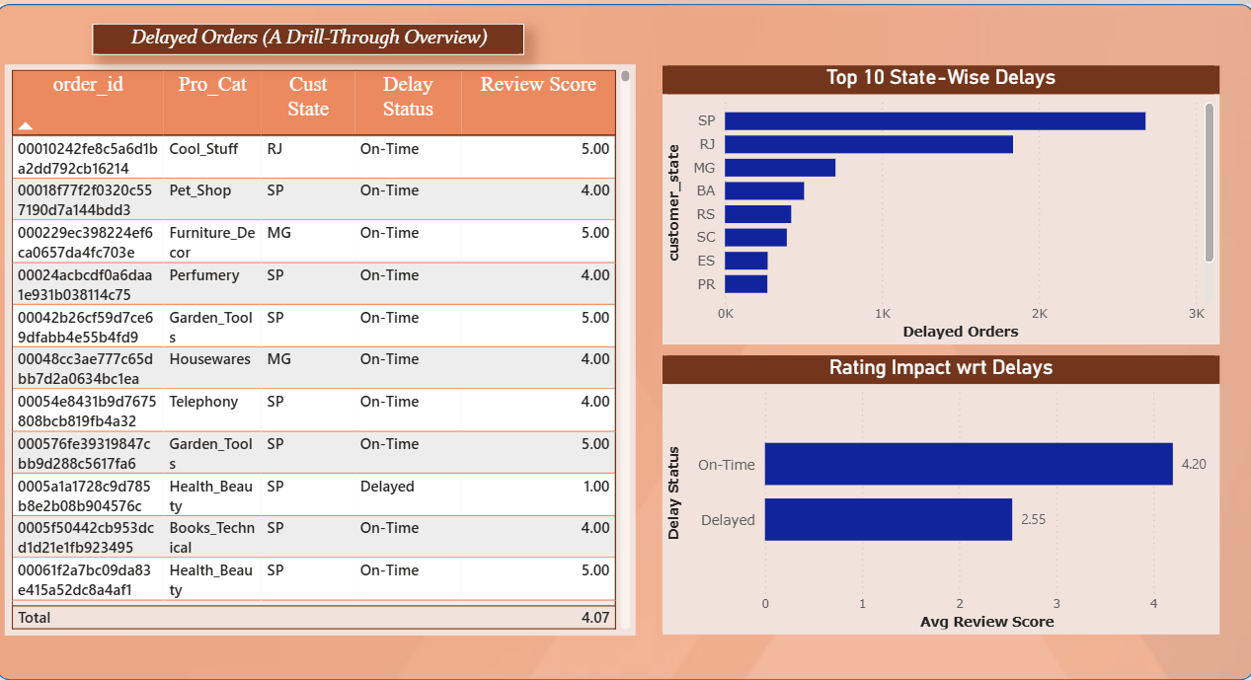

(Under TASK 3)
- ADDITIONAL ANALYSIS: Monthly Orders Trend
A significant analytical relationship can be observed between the Monthly Comparison of Delayed vs On-Time Deliveries and the Monthly Orders Trend.
An important question is whether delivery delays are associated with higher order volumes. In some months, higher order volumes may slightly increase the likelihood of delivery delays due to greater pressure on logistics operations. However, the analysis also shows that this relationship is not always consistent.

Monthly Orders Trend Chart:
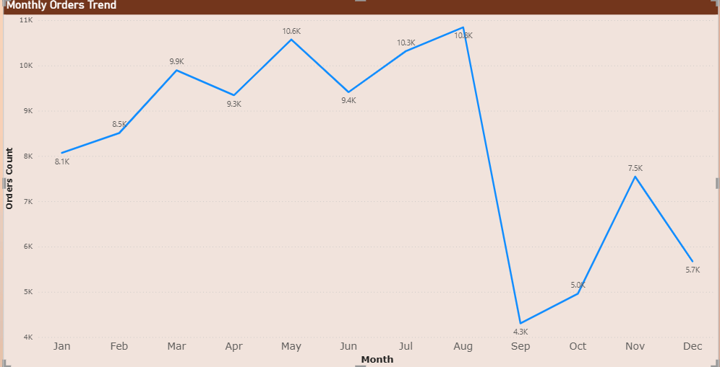

For example, even during months with high order volumes such as August, the number of delayed deliveries may remain comparatively lower than in November which has a comparatively lower number of orders strength. Similar patterns can be drawn between June & September.

The analysis indicates that order volume does not have a consistent or direct correlation with delivery delays. While it might be expected that higher order volumes would lead to more delayed deliveries due to increased operational pressure, the observed trends show otherwise.

In some months with higher order counts, on-time deliveries remain high, whereas in certain months with lower order volumes, delayed deliveries are relatively higher.

This suggests that delivery performance is influenced not only by the number of orders but also by other operational factors such as logistics efficiency, warehouse processing capacity, transportation availability, and supply chain management. Therefore, the company should further investigate these operational aspects to better understand and minimize delivery delays.

TASK 4: Payment Method Distribution
Question: What are the most commonly used payment methods by customers on the ShopNest platform?
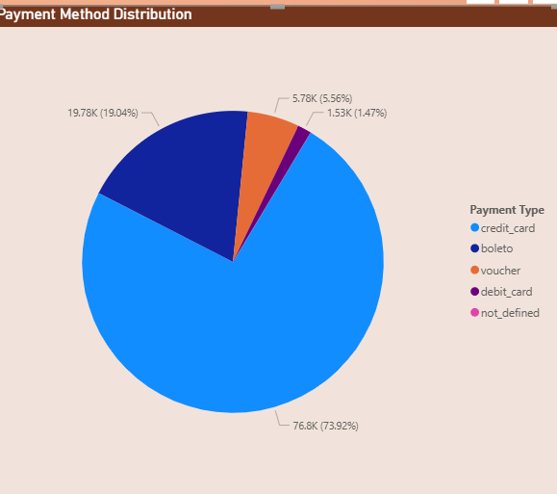
This chart illustrates the distribution of payment methods used by customers, such as credit card, debit card, boleto, or vouchers. Understanding payment preferences helps businesses improve the checkout experience and prioritize the most widely used payment options. It also provides insight into customer behavior and transaction patterns within the e-commerce platform.

Key Insights and Findings:
- Credit Card is the most commonly used payment method, indicating that customers prefer faster and more convenient digital payment options for online transactions.
- Boleto ranks second, suggesting that a significant portion of customers still rely on traditional or bank-based payment methods.
- Voucher payments appear less frequently, indicating they are used mainly in specific cases such as promotional offers or credits.
- Debit Card has the lowest usage, which may suggest limited availability, lower customer preference, or fewer incentives compared to credit card payments.

TASK 5: Product Rating Analysis
Question: Which products receive the highest and lowest customer ratings?
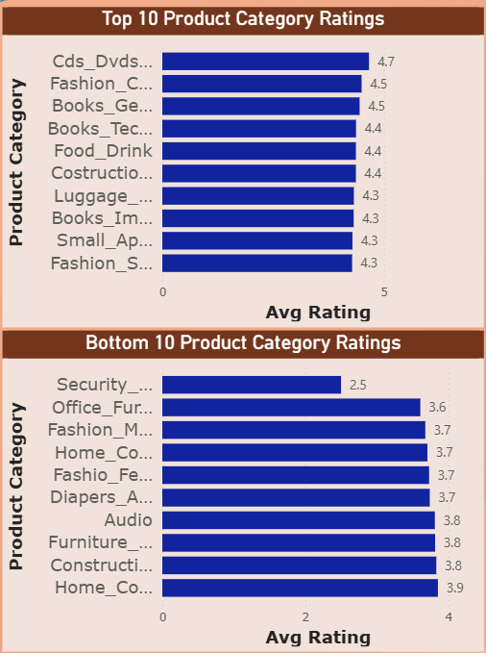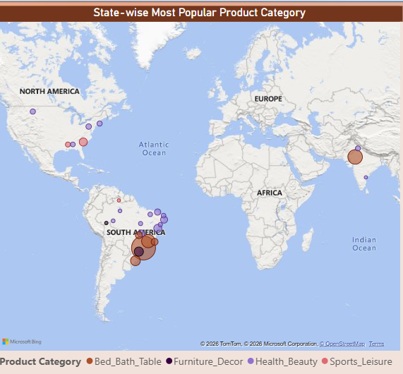
Customer reviews are an important indicator of product quality and satisfaction. These charts display the top 10 highest-rated products and the bottom 10 lowest-rated products based on average review scores. High-rated products indicate strong customer satisfaction, while low-rated products may signal quality issues or unmet expectations. This analysis helps businesses identify products that perform well and those that require improvement or further investigation.

Key Insights and Findings:
- Products related to entertainment, children's clothings, books, etc show the highest customer satisfaction, while security equipment, office furniture, male and female clothing categories receive comparatively lower ratings.

- ADDITIONAL ANALYSIS: Map- State-Wise Most Popular Product Category
The map displays the most frequently ordered product category in each state, represented using colored bubbles. The bubble size indicates the volume of orders, while the color represents the dominant product category in that region.
- Home-related products such as Bed Bath Table and Furniture Decor dominate customer purchases across multiple states, while Health Beauty and Sports Leisure categories also show notable regional popularity.

TASK 6: State-wise Sales Analysis
Question: How are sales distributed across different states in Portugal?

This visualization represents the geographical distribution of sales across different states. It highlights regions where the ShopNest store generates the highest revenue and areas with lower purchasing activity. Understanding regional sales performance helps businesses identify strong markets and potential regions for expansion. It can also assist in optimizing logistics, marketing campaigns, and regional product promotions.

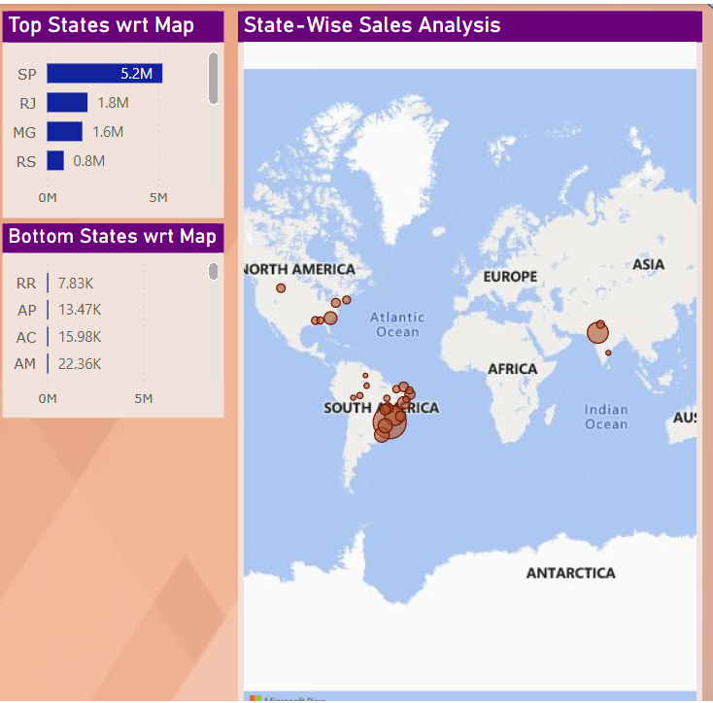

Key Insights and Findings:
- São Paulo, Rio de Janeiro, and Minas Gerais contribute the highest sales, indicating that the ShopNest platform has the strongest customer presence in these economically developed regions.
- Roraima, Amapá, and Acre show the lowest sales, likely due to smaller populations and lower e-commerce activity.
- The results suggest that online shopping activity is concentrated in major urban and economically developed regions.

TASK 7: Seasonal Sales Pattern
Question: How do sales vary across different quarters of the year?
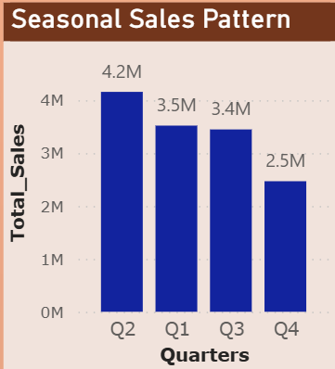
The seasonal sales pattern analysis examines changes in sales performance across different quarters. Seasonal trends may arise due to holidays, promotional campaigns, or changes in consumer demand. Identifying these patterns helps businesses prepare for peak shopping periods and adjust inventory levels accordingly. Understanding seasonality is essential for effective sales forecasting and strategic planning.

Key Insights and Findings:

- Q2 (Apr, May, Jun) records the highest sales (4.2M), indicating the peak purchasing period for the ShopNest store.
- Q1 and Q3 show relatively similar sales levels (3.5M and 3.4M), suggesting stable demand during these periods.
- Q4 (Oct, Nov, Dec) has the lowest sales (2.5M), indicating a noticeable decline in customer purchases toward the end of the year.
Overall, sales appear to peak in the middle of the year and gradually decline afterward, reflecting a seasonal variation in customer purchasing behavior.

TASK 8: Revenue Analysis
Question: Determine the total revenue generated by the ShopNest store and analyze how it changes over time on a yearly basis.
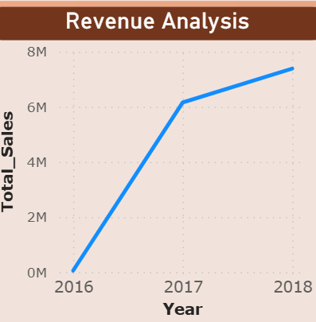
Yearly Revenue generated by ShopNest Store:
2016 - R$ 49,785.92 2017- R$ 6155806.98 2018- R$ 7386050.80
Net Revenue= R$ 16.01 M

Key Insights – Yearly Revenue Analysis:
- Revenue shows significant growth from 2016 to 2018. Sales increased from R$ 49,785.92 in 2016 to R$ 6.16 million in 2017, indicating a major expansion in business activity.
- 2018 records the highest revenue (R$ 7.39 million), reflecting continued growth and increased customer adoption of the ShopNest platform.
- The very low revenue in 2016 suggests the platform was likely in its early operational stage, with fewer orders and limited market presence.
- The trend indicates rapid business growth between 2017 and 2018, showing that the e-commerce platform gained strong market traction during these years.
- Total net revenue across the dataset amounts to approximately R$ 16.01 million, demonstrating the overall financial performance of the ShopNest store during the analyzed period.

CONCLUSION OF THE REPORT

This dashboard analysis of the ShopNest e-commerce dataset provides valuable insights into the store’s sales performance, operational efficiency, and customer product preferences. The visualizations highlight key trends such as revenue growth over time, regional variations in sales, delivery performance patterns, and differences in product ratings across categories.
The analysis shows that sales activity is concentrated in major regions, certain product categories dominate customer demand, and customer satisfaction varies across product segments. Additionally, the dashboard structure enables interactive exploration of operational and product-level insights through filters and navigation features.
Overall, the Power BI dashboard provides a clear and comprehensive view of the ShopNest store’s business performance and can assist decision-makers in understanding sales patterns, improving logistics efficiency, and identifying high-performing product categories.

